For the user interface the grid shown in figure 1 below will be used to show the location of obstacles, the robots, the mission objective, empty and unexplored areas and the robots routes. Table 1 below highlights what each colour represents.

Table 1. Map colour meaning

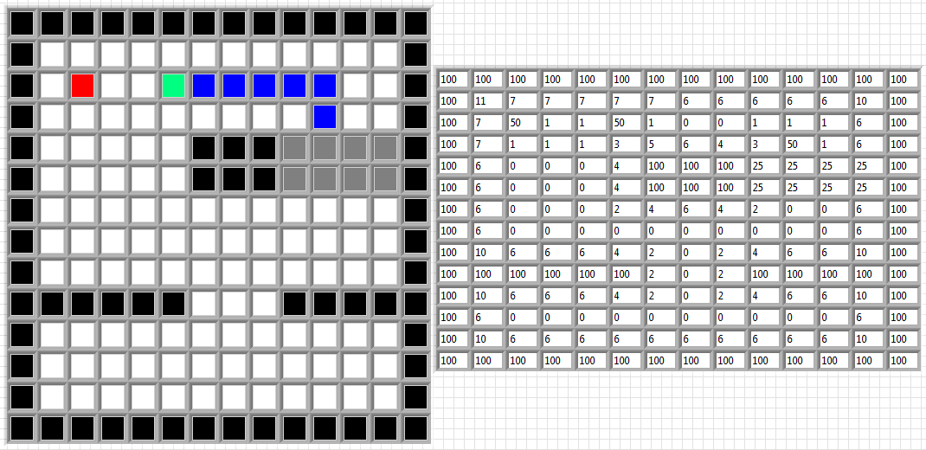

Figure 1. User interface map

In order for the DaNI to move around it has to make a decision on where to move. A system called the Priority system has been created in order for the DaNI to decide on the best place to move is. This system works by analysing the pre-existing map to locate areas that have not been explored and chose which area to move to based on the DaNI’s proximity to these areas. In order to decide whether the DaNI should move to a certain area each coordinate analyses what is located around it. Each coordinate is given a value of 15 to start with and then the value is increased or decreased depending on what the neighbouring areas are. For example if there is a wall next to a coordinate its value will decrease by 2 or if the area is an unexplored area its value will increase by 2, a full table of conditions and value increase and decrease amounts can be found below in table 2. Using this method the area with the highest value should be near unexplored areas and away from walls. Below figure 2 shows an example map on the right and a grid showing each coordinates priority score. The highest score is 24 and three areas have this score so the DaNI will move to the closest area which is coordinate 5,2.

Table 2. Priority system conditions and increase/decrease values

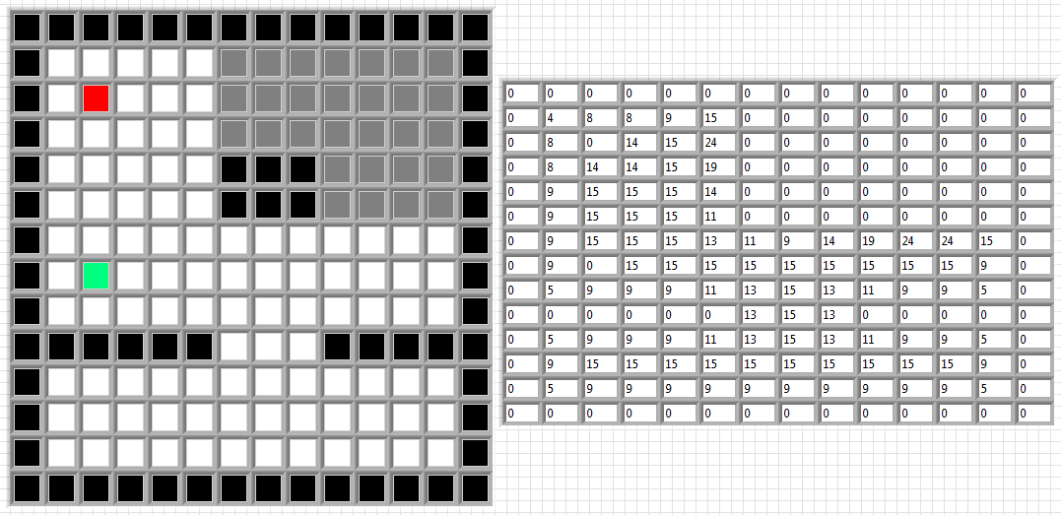

Figure 2. Example map

Now the DaNI knows its target location it can calculate the safest route to the target location. The same method as above can be used to calculate the safest route with a few alteration to the score system. The safest route is worked out using the A\* route plan on Labview. The A\* plan works by finding the quickest route between 2 points but the each square can be weighted to make it less likely to be used, where the lower the weighting the more likely to be used. What has been done to keep the DaNI away from walls and other areas is each area starts with score of zero and the areas score increases by a number of points for nearby adjacent area depending on what it contains. The score is also changed depending on what each coordinate is. For example if the area is a wall it will atomatily gain 100 points as the DaNI cannot go in this area. A full table of these point increase and decrease values can be found below in table 3. Figure 3 below shows the grid of each areas weighting score on the right and the chosen route highlighted in blue on the left.

Table 3. A\* plan weighting condition and point increase/decrease values

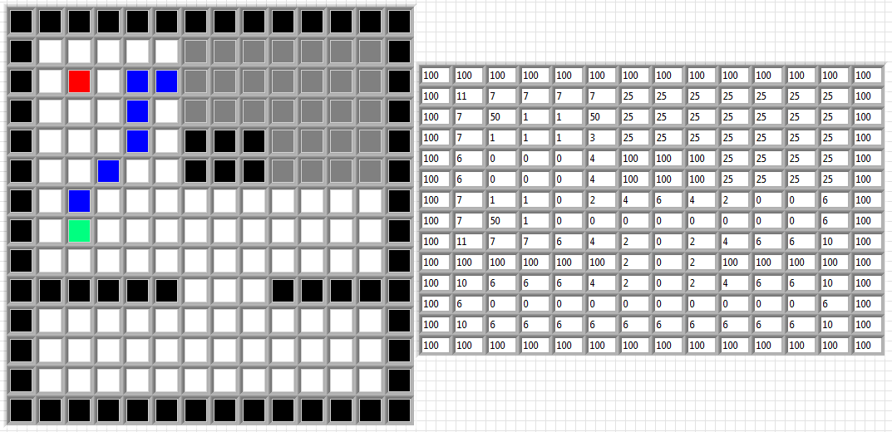

Figure 3. Example map with route

Once the DaNI has moved to the target area it will use the Kinect to see if the unexplored area has any obstacles in it and update the map. The process is then started again and a new target location and route is chosen as shown below in figure 4. The DaNI will keep exploring areas till all areas have been explored and then it will return home.



Figure 4. Example map after DaNI has moved